CARDIAC ARRHYTHMIA DETECTION USING CLASSIFICATION TECHNIQUE

Sritharan Mahendra Babu
Mahendrababu.s@husky.neu.edu

Abstract

Cardiac Arrhythmias are any of a group of conditions in which the electrical activity of the heart is irregular or is faster or slower than normal. Cardiac arrhythmia, also known as cardiac dysrhythmia or irregular heartbeat, is a group of conditions in which the heartbeat is irregular, too fast, or too slow. It is the leading cause of death related to heart for both men and women in the world. Heart diseases kill more than 400,000 people annually. In the United States, someone has a heart attack every 34 seconds. This paper aims to detect and classify arrhythmia into 16 different variants using different types of classifier.

Introduction
Irregularity in heart beat may be harmless or life threatening. Cardiac Arrhythmia acts as a precursory diagnosis to the Cardiac/Heart Attack. Cardiac Arrhythmia can be diagnosed by measuring the heart activity using an instrument called ECG or electrocardiograph. Different parameter values can be extracted from the ECG and can be used along with other details about the patient like age, medical history, etc. to detect cardiac arrhythmia. Using machine learning cardiac arrhythmia diagnosis can be very helpful. The project aims at using different machine learning algorithms like Logistic Regression, SVM for predicting and classifying cardiac arrhythmia into different categories.

Existing Methods
The most traditional method of Cardiac Arrhythmia detection is done by doctors or physicians to look at these long duration ECG recordings and find minute irregularities in the obtained recordings. There are various other hardware devices to do the analysis of the ECG recordings to detect Cardiac Arrhythmia but it involves human involvement or assistance to understand the ECG recordings to analyze the disease.

Overall Approach
I am planning on approaching this problem using machine learning algorithms which I learnt during my course work. I am primarily using two major Classifiers to predict or classify the dataset for Cardiac Arrhythmia. The classifiers are namely:
- Logistic Regression
Logistic regression measures the relationship between the categorical dependent variable and one or more independent variables by estimating probabilities using a logistic function.

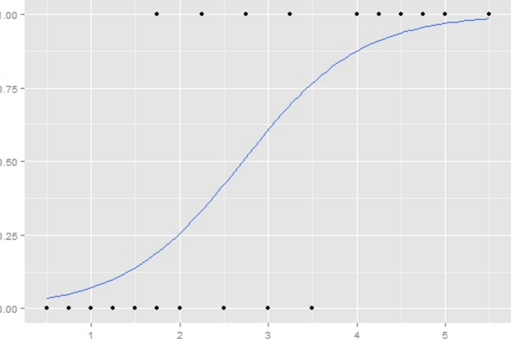
- SVM (Support Vector Machines)
Support vector machines (SVMs, also support vector network) are supervised learning models with associated learning algorithms that analyze data used for classification and regression analysis. Given a set of training examples, each marked as belonging to one or the other of two categories, an SVM training algorithm builds a model that assigns new examples to one category or the other.

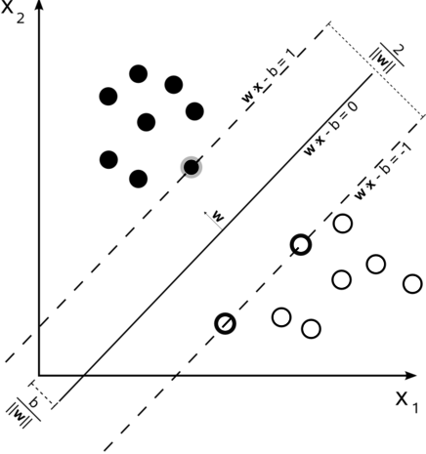
Using these two algorithms / classifiers is a very high level approach of this project. The detailed approach involves more data preprocessing and data analysis such feature selection and dimensionality reduction to increase the accuracy of the classifier / estimator.

Proposed or Studied Approach
I am using Logistic Regression and SVM as the primary estimator / classifier for performing the prediction. But the data needs to be pre-processed even before it is fed as the train or test data to the estimators.

Details of the Study
I am using a mid-scale dataset which has been obtained from University of California Irvine. This dataset is recorded on various patients using ECG machine.
- Firstly, I am reading the dataset from a csv using pandas to transform the data into a panda’s data frame
- Secondly I had to clean the data as I contains unknown variables and the data type varies between integer and float

Mathematics
Please number all of your sections and displayed equations. It is important for readers to be able to refer to any particular equation. Just because you didn’t refer to it in the text doesn’t mean some future reader might not need to refer to it. It is cumbersome to have to use circumlocutions like “the equation second from the top of page 3 column 1”. (Note that the ruler will not be present in the final copy, so is not an alternative to equation numbers). All authors will benefit from reading Mermin’s description of how to write mathematics: http://www.pamitc.org/documents/mermin.pdf. Every equation should be numbered, even if you don't refer to it!

Blind review
Figure 1: Example of a figure with caption. Captions are set in roman, 9 point. Use a Drawing area to make space for figures.
Many authors misunderstand the concept of anonymizing for blind review. Blind review does not mean that one must remove citations to one’s own work—in fact it is often impossible to review a paper unless the previous citations are known and available.
Blind review means that you do not use the words “my” or “our” when citing previous work. That is all. (But see below for techreports)
Saying “this builds on the work of Lucy Smith [1]” does not say that you are Lucy Smith, it says that you are building on her work. If you are Smith and Jones, do not say “as we show in [7]”, say “as Smith and Jones show in [7]” and at the end of the paper, include reference 7 as you would any other cited work.
An example of a bad paper:

An analysis of the frobnicatable foo filter.
In this paper we present a performance analysis
of our previous paper [1], and show it to be inferior
to all previously known methods. Why the
previous paper was accepted without this analysis
is beyond me.
[1] Removed for blind review

An example of an excellent paper:

An analysis of the frobnicatable foo filter.
In this paper we present a performance analysis of
the paper of Smith et al. [1], and show it to be
inferior to all previously known methods. Why the
previous paper was accepted without this analysis
is beyond me.
[1] Smith, L and Jones, C. “The frobnicatable
foo filter, a fundamental contribution to human
knowledge”. Nature 381(12), 1-213.

If you are making a submission to another conference at the same time, which covers similar or overlapping material, you may need to refer to that submission in order to explain the differences, just as you would if you had previously published related work. In such cases, include the anonymized parallel submission [4] as additional material and cite it as
[1] Authors. “The frobnicatable foo filter”, Face and Gesture 2014 submission ID 324, Supplied as additional material efg324.pdf.
Finally, you may feel you need to tell the reader that more details can be found elsewhere, and refer them to a technical report. For conference submissions, the paper must stand on its own, and not require the reviewer to go to a techreport for further details. Thus, you may say in the body of the paper “further details may be found in [5]”. Then submit the techreport as additional material. Again, you may not assume the reviewers will read this material.
Sometimes your paper is about a problem which you tested using a tool which is widely known to be restricted to a single institution. For example, let’s say it’s 1969, you have solved a key problem on the Apollo lander, and you believe that the CVPR70 audience would like to hear about your solution. The work is a development of your celebrated 1968 paper entitled ”Zero-g frobnication: How being the only people in the world with access to the Apollo lander source code makes us a wow at parties”, by Zeus et al.
You can handle this paper like any other. Don’t write “We show how to improve our previous work [Anonymous, 1968]. This time we tested the algorithm on a lunar lander [name of lander removed for blind review]”. That would be silly, and would immediately identify the authors. Instead write the following:
We describe a system for zero-g frobnication. This system is new because it handles the following cases: A, B. Previous systems [Zeus et al. 1968] didn’t handle case B properly. Ours handles it by including a foo term in the bar integral.
...
The proposed system was integrated with the Apollo lunar lander, and went all the way to the moon, don’t you know. It displayed the following behaviours which show how well we solved cases A and B: ...
As you can see, the above text follows standard scientific convention, reads better than the first version, and does not explicitly name you as the authors. A reviewer might think it likely that the new paper was written by Zeus et al, but cannot make any decision based on that guess. He or she would have to be sure that no other authors could have been contracted to solve problem B.

Miscellaneous
When citing a multi-author paper, you may save space by using “et alia”, shortened to “et al.” (not “et. al.” as “et” is a complete word.) However, use it only when there are three or more authors. Thus, the following is correct:
“Frobnication has been trendy lately. It was introduced
by Alpher [3], and subsequently developed by Alpher and Fotheringham-Smythe [1], and Alpher et al. [2].”
This is incorrect: “... subsequently developed by Alpher et al. [1] ...” because reference [1] has just two authors. If you use the \etal macro provided, then you need not worry about double periods when used at the end of a sentence as in Alpher et al.
For this citation style, keep multiple citations in numerical (not chronological) order, so prefer [1, 3, 4] to [3, 1, 4].

Formatting your paper
All text must be in a two-column format. The total allowable width of the text area is 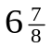inches (17.5 cm) wide by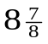inches (22.54 cm) high. Columns are to be 31/4 inches (8.25 cm) wide, with a 5/16 inch (0.8 cm) space between them. The main title (on the first page) should begin 1.0 inch (2.54 cm) from the top edge of the page. The second and following pages should begin 1.0 inch (2.54 cm) from the top edge. On all pages, the bottom margin should be 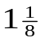inches (2.86 cm) from the bottom edge of the page for 8.5 × 11-inch paper; for A4 paper, approximately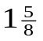inches (4.13 cm) from the bottom edge of the page.

Margins and page numbering
Figure 2: Short captions should be centred.
All printed material, including text, illustrations, and charts, must be kept within a print area inches (17.5 cm) wide by inches (22.54 cm) high. Page numbers should be in footer with page numbers, centered and .75 inches from the bottom of the page and make it start at the correct page number rather than the 4321 in the example (how to do that depends on your version of word or open office. Failure to use the correct page number, or place it properly, could result in the paper not being included in Xplore, (even if it passes PDF express (which does not check page number)

Type-style and fonts
Wherever Times is specified, Times Roman may also be used. If neither is available on your word processor, please use the font closest in appearance to Times to which you have access.
MAIN TITLE. Center the title 1-3/8 inches (3.49 cm) from the top edge of the first page. The title should be in Times 14-point, boldface type. Capitalize the first letter of nouns, pronouns, verbs, adjectives, and adverbs; do not capitalize articles, coordinate conjunctions, or prepositions (unless the title begins with such a word). Leave two blank lines after the title.
AUTHOR NAME(s) and AFFILIATION(s) are to be centered beneath the title and printed in Times 12-point, non-boldface type. This information is to be followed by two blank lines.
The ABSTRACT and MAIN TEXT are to be in a twocolumn format.
MAIN TEXT. Type main text in 10-point Times, singlespaced. Do NOT use double-spacing. All paragraphs should be indented 1 pica (approx. 1/6 inch or 0.422 cm). Make sure your text is fully justified—that is, flush left and flush right. Please do not place any additional blank lines between paragraphs.
Figure and table captions should be 9-point Roman type as in Figures 1 and 2. Short captions should be centred. Callouts should be 9-point Helvetica, non-boldface type. Initially capitalize only the first word of section titles and first-, second-, and third-order headings.
FIRST-ORDER HEADINGS. (For example, 1. Introduction) should be Times 12-point boldface, initially capitalized, flush left, with one blank line before, and one blank line after.
SECOND-ORDER HEADINGS. Should be Times 11-point boldface, initially capitalized, flush left, with one blank line before, and one after. If you require a third-order heading (we discourage it), use 10-point Times, boldface, initially capitalized, flush left, preceded by one blank line, followed by a period and your text on the same line.

Footnotes
Please use footnotes sparingly. Indeed, try to avoid footnotes altogether and include necessary peripheral observations in the text (within parentheses, if you prefer, as in this sentence). If you wish to use a footnote, place it at the bottom of the column on the page on which it is referenced. Use Times 8-point type, single-spaced.

References
List and number all bibliographical references in 9-point Times, single-spaced, at the end of your paper. When referenced in the text, enclose the citation number in square brackets, for example [4]. Where appropriate, include the name(s) of editors of referenced books.

Illustrations, graphs, and photographs
All graphics should be centered. Please ensure that any point you wish to make is resolvable in a printed copy of the paper. Resize fonts in figures to match the font in the body text, and choose line widths which render effectively in print. Many readers (and reviewers), even of an electronic copy, will choose to print your paper in order to read it.
You cannot insist that they do otherwise, and therefore must not assume that they can zoom in to see tiny details on a graphic. When placing figures in LATEX, it’s almost always best to use \includegraphics, and to specify the figure width as a multiple of the line width as in the example below

\usepackage[dvips]{graphicx} ...
\includegraphics[width=0.8\linewidth]
{myfile.eps}

Color
Please refer to the author guidelines on the CVPR 2017 web page for a discussion of the use of color in your document.

Final copy
You must include your signed IEEE copyright release form when you submit your finished paper. We MUST have this form before your paper can be published in the proceedings. Please direct any questions to the production editor in charge of these proceedings at the IEEE Computer Society Press: Phone (714) 821-8380, or Fax (714) 761-1784.

References
- A. Alpher, , and J. P. N. Fotheringham-Smythe. Frobnication revisited. Journal of Foo, 13(1):234–778, 2003.
- A. Alpher, , J. P. N. Fotheringham-Smythe, and G. Gamow. Can a machine frobnicate? Journal of Foo, 14(1):234–778, 2004.
- A. Alpher. Frobnication. Journal of Foo, 12(1):234–778, 2002.
- Actual Author Name. The frobnicatable foo filter, 2014. Face and Gesture (to appear ID 324).
- Actual Author Name. Frobnication tutorial, 2014. Some URL al tr.pdf.

This is what a footnote looks like. It often distracts the reader from the main flow of the argument.

